Dynamic Memory Allocation in C using malloc(), calloc(), free() and realloc()

Since C is a structured language, it has some fixed rules for programming. One of it includes changing the size of an array. An array is collection of items stored at continuous memory locations.  
[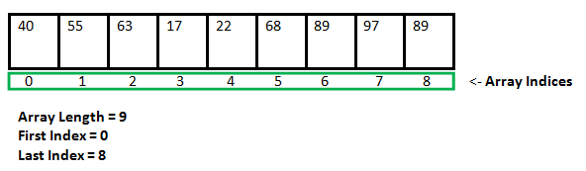](https://media.geeksforgeeks.org/wp-content/cdn-uploads/gq/2015/05/Arrays.png)

As it can be seen that the length (size) of the array above made is 9. But what if there is a requirement to change this length (size). For Example,

* If there is a situation where only 5 elements are needed to be entered in this array. In this case, the remaining 4 indices are just wasting memory in this array. So there is a requirement to lessen the length (size) of the array from 9 to 5.

* Take another situation. In this, there is an array of 9 elements with all 9 indices filled. But there is a need to enter 3 more elements in this array. In this case 3 indices more are required. So the length (size) of the array needs to be changed from 9 to 12.

This procedure is referred to as **Dynamic Memory Allocation in C**.

Therefore, C **Dynamic Memory Allocation** can be defined as a procedure in which the size of a data structure (like Array) is changed during the runtime.

C provides some functions to achieve these tasks. There are 4 library functions provided by C defined under **<stdlib.h>** header file to facilitate dynamic memory allocation in C programming. They are:

1. malloc()
2. calloc()
3. free()
4. realloc()

Let’s look at each of them in greater detail.

1. **C malloc() method**

**“malloc”** or **“memory allocation”** method in C is used to dynamically allocate a single large block of memory with the specified size. It returns a pointer of type void which can be cast into a pointer of any form.

**Syntax:**

ptr = (cast-type*) malloc(byte-size)

**For Example:**

***ptr = (int*) malloc(100 * sizeof(int));***

*Since the size of int is 4 bytes, this statement will allocate 400 bytes of memory. And, the pointer ptr holds the address of the first byte in the allocated memory.*

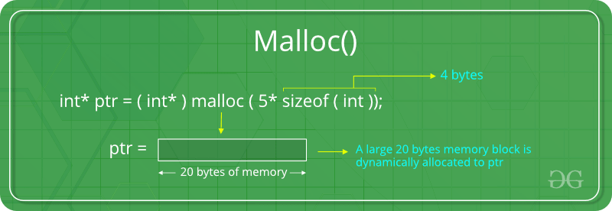

If space is insufficient, allocation fails and returns a NULL pointer.

**Example:**

filter_none

edit

play_arrow

brightness_4

|  |
| --- |
| #include <stdio.h>  #include <stdlib.h>    int main()  {        // This pointer will hold the      // base address of the block created      int* ptr;      int n, i;        // Get the number of elements for the array      n = 5;      printf("Enter number of elements: %d\n", n);        // Dynamically allocate memory using malloc()      ptr = (int*)malloc(n * sizeof(int));        // Check if the memory has been successfully      // allocated by malloc or not      if (ptr == NULL) {          printf("Memory not allocated.\n");          exit(0);      }      else {            // Memory has been successfully allocated          printf("Memory successfully allocated using malloc.\n");            // Get the elements of the array          for (i = 0; i < n; ++i) {              ptr[i] = i + 1;          }            // Print the elements of the array          printf("The elements of the array are: ");          for (i = 0; i < n; ++i) {              printf("%d, ", ptr[i]);          }      }        return 0;  } |

**Output:**

Enter number of elements: 5

Memory successfully allocated using malloc.

The elements of the array are: 1, 2, 3, 4, 5,

1. **C calloc() method**

**“calloc”** or **“contiguous allocation”** method in C is used to dynamically allocate the specified number of blocks of memory of the specified type. It initializes each block with a default value ‘0’.

**Syntax:**

ptr = (cast-type*)calloc(n, element-size);

**For Example:**

***ptr = (float*) calloc(25, sizeof(float));***

*This statement allocates contiguous space in memory for 25 elements each with the size of the float.*

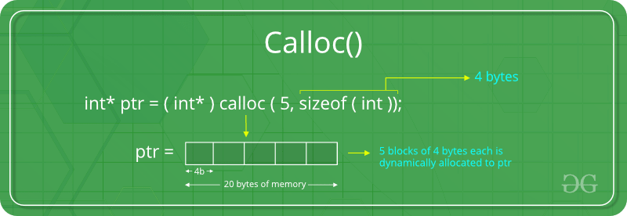

If space is insufficient, allocation fails and returns a NULL pointer.

**Example:**

filter_none

edit

play_arrow

brightness_4

|  |
| --- |
| #include <stdio.h>  #include <stdlib.h>    int main()  {        // This pointer will hold the      // base address of the block created      int* ptr;      int n, i;        // Get the number of elements for the array      n = 5;      printf("Enter number of elements: %d\n", n);        // Dynamically allocate memory using calloc()      ptr = (int*)calloc(n, sizeof(int));        // Check if the memory has been successfully      // allocated by calloc or not      if (ptr == NULL) {          printf("Memory not allocated.\n");          exit(0);      }      else {            // Memory has been successfully allocated          printf("Memory successfully allocated using calloc.\n");            // Get the elements of the array          for (i = 0; i < n; ++i) {              ptr[i] = i + 1;          }            // Print the elements of the array          printf("The elements of the array are: ");          for (i = 0; i < n; ++i) {              printf("%d, ", ptr[i]);          }      }        return 0;  } |

**Output:**

Enter number of elements: 5

Memory successfully allocated using calloc.

The elements of the array are: 1, 2, 3, 4, 5,

1. **C free() method**

**“free”** method in C is used to dynamically **de-allocate** the memory. The memory allocated using functions malloc() and calloc() is not de-allocated on their own. Hence the free() method is used, whenever the dynamic memory allocation takes place. It helps to reduce wastage of memory by freeing it.

**Syntax:**

free(ptr);

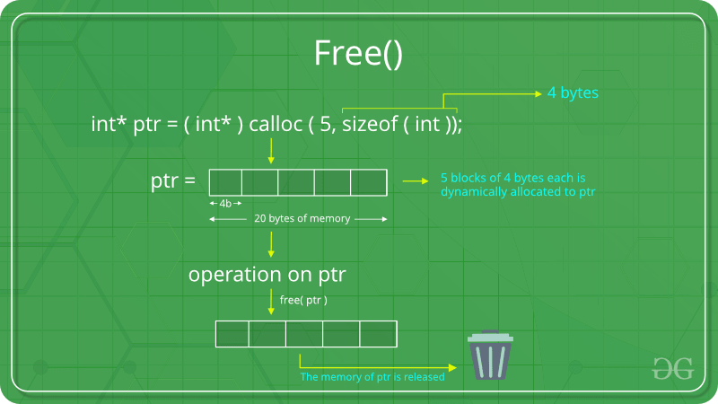

**Example:**

filter_none

edit

play_arrow

brightness_4

|  |
| --- |
| #include <stdio.h>  #include <stdlib.h>    int main()  {        // This pointer will hold the      // base address of the block created      int *ptr, *ptr1;      int n, i;        // Get the number of elements for the array      n = 5;      printf("Enter number of elements: %d\n", n);        // Dynamically allocate memory using malloc()      ptr = (int*)malloc(n * sizeof(int));        // Dynamically allocate memory using calloc()      ptr1 = (int*)calloc(n, sizeof(int));        // Check if the memory has been successfully      // allocated by malloc or not      if (ptr == NULL || ptr1 == NULL) {          printf("Memory not allocated.\n");          exit(0);      }      else {            // Memory has been successfully allocated          printf("Memory successfully allocated using malloc.\n");            // Free the memory          free(ptr);          printf("Malloc Memory successfully freed.\n");            // Memory has been successfully allocated          printf("\nMemory successfully allocated using calloc.\n");            // Free the memory          free(ptr1);          printf("Calloc Memory successfully freed.\n");      }        return 0;  } |

**Output:**

Enter number of elements: 5

Memory successfully allocated using malloc.

Malloc Memory successfully freed.

Memory successfully allocated using calloc.

Calloc Memory successfully freed.

1. **C realloc() method**

**“realloc”** or **“re-allocation”** method in C is used to dynamically change the memory allocation of a previously allocated memory. In other words, if the memory previously allocated with the help of malloc or calloc is insufficient, realloc can be used to **dynamically re-allocate memory**.

**Syntax:**

ptr = realloc(ptr, newSize);

where ptr is reallocated with new size 'newSize'.

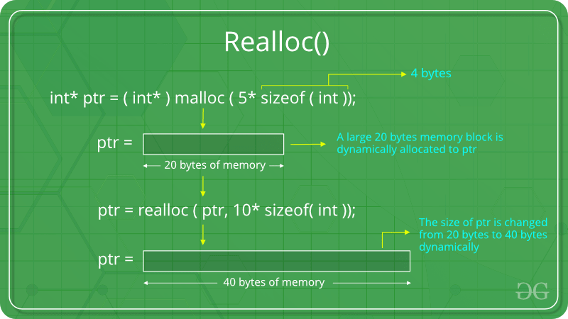

If space is insufficient, allocation fails and returns a NULL pointer.

**Example:**

filter_none

edit

play_arrow

brightness_4

|  |
| --- |
| #include <stdio.h>  #include <stdlib.h>    int main()  {        // This pointer will hold the      // base address of the block created      int* ptr;      int n, i;        // Get the number of elements for the array      n = 5;      printf("Enter number of elements: %d\n", n);        // Dynamically allocate memory using calloc()      ptr = (int*)calloc(n, sizeof(int));        // Check if the memory has been successfully      // allocated by malloc or not      if (ptr == NULL) {          printf("Memory not allocated.\n");          exit(0);      }      else {            // Memory has been successfully allocated          printf("Memory successfully allocated using calloc.\n");            // Get the elements of the array          for (i = 0; i < n; ++i) {              ptr[i] = i + 1;          }            // Print the elements of the array          printf("The elements of the array are: ");          for (i = 0; i < n; ++i) {              printf("%d, ", ptr[i]);          }            // Get the new size for the array          n = 10;          printf("\n\nEnter the new size of the array: %d\n", n);            // Dynamically re-allocate memory using realloc()          ptr = realloc(ptr, n * sizeof(int));            // Memory has been successfully allocated          printf("Memory successfully re-allocated using realloc.\n");            // Get the new elements of the array          for (i = 5; i < n; ++i) {              ptr[i] = i + 1;          }            // Print the elements of the array          printf("The elements of the array are: ");          for (i = 0; i < n; ++i) {              printf("%d, ", ptr[i]);          }            free(ptr);      }        return 0;  } |

**Output:**

Enter number of elements: 5

Memory successfully allocated using calloc.

The elements of the array are: 1, 2, 3, 4, 5,

Enter the new size of the array: 10

Memory successfully re-allocated using realloc.

The elements of the array are: 1, 2, 3, 4, 5, 6, 7, 8, 9, 10,